**Blob Storage Container:**

This is the container where temporary files will be stored (for database and windows file loads)

A BLOB Storage Container is similar to an S3 Bucket in many ways.

You can see them in the Azure Portal as shown below.

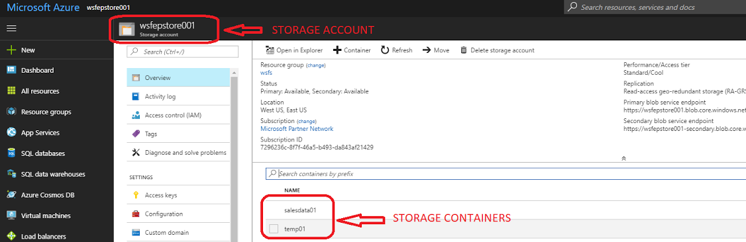

**Blob Data Source:**

This is the **database object** which links the Blob Storage Container to the database

These are created using the **CREATE EXTERNAL DATA SOURCE** SQL command documented here: <https://docs.microsoft.com/en-us/sql/t-sql/statements/create-external-data-source-transact-sql>

The example in the article above which will be most useful to you is **EXAMPLE G: Create external data source to reference Azure blob storage** under the **Azure SQL Data Warehouse**section.

You will need an access key to create a **DATABASE SCOPED CREDENTIAL** which is a **PREREQUISITE** to creating an **EXTERNAL DATA SOURCE**

You can find the access keys for the container in the Azure Portal as obfuscated in the screenshot below.

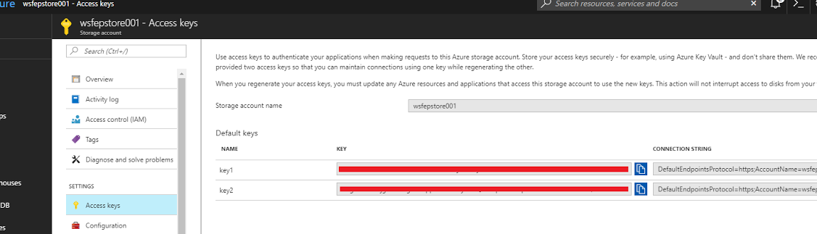

You can check to see if any of these exist by running

SELECT * FROM sys.external_data_sources

This will show you all available external data sources and the locations they refer to.

This is either used to load data from temporary file storage (for database or windows file loads) or to load pre-existing data in azure blob storage (for blob storage loads)

**BLOB Data Source / BLOB Storage Container Extended Property Requirement Matrix**

|  |  |  |
| --- | --- | --- |
| **Load Type** | **BLOB Data Source** | **BLOB Storage Container** |
| Database Load | REQUIRED | REQUIRED |
| Windows File Load | REQUIRED | REQUIRED |
| BLOB Storage File Load | REQUIRED | NOT REQUIRED |

**Load Process Diagram**

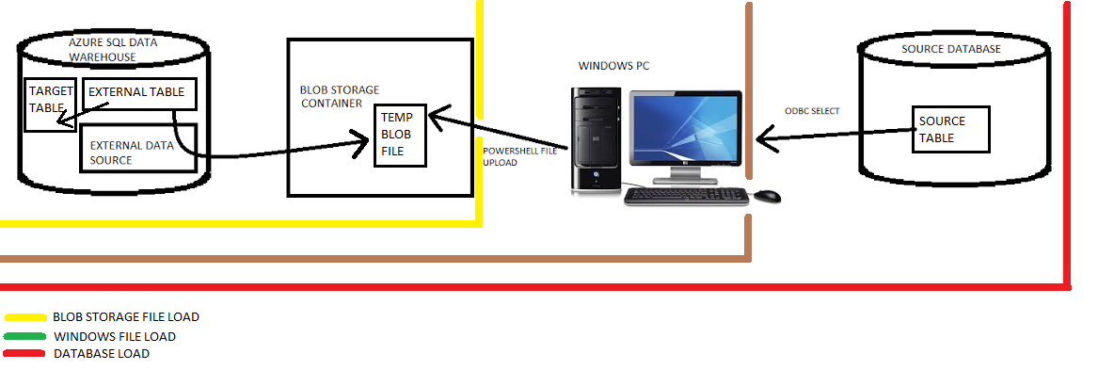

**Extended Property Hierarchy**

|  |  |  |
| --- | --- | --- |
| **Value Set On** | **Value Available On** | **Value Priority** |
| Target Table | Target table | 1 - if set overrides all other values |
| Source Connection | All tables sourced from connection | 2 - if set overrides values on target connection |
| Target Connection | All tables in target | 3 - does not override any values  use this as the default then override at a more granular level as required |

**External Data Source SQL Syntax for Azure SQL DW**

-- Create a database master key if one does not already exist. This key is used to encrypt   
-- the credential secret in next step.

CREATE MASTER KEY;

-- Create a database scoped credential with Azure storage account key as the secret.

CREATE DATABASE SCOPED CREDENTIAL AzureStorageCredential  
 WITH IDENTITY = '<blob_storage_account_name>',  
 SECRET = '<azure_storage_account_key>';

-- Create an external data source with CREDENTIAL option.

CREATE EXTERNAL DATA SOURCE MyAzureStorage   
WITH (  
 TYPE = HADOOP,  
 LOCATION ='wasbs://<wherescape_temp_container_name>@<blob_storage_account_name>.blob.core.windows.net/',  
 CREDENTIAL = AzureStorageCredential   
);